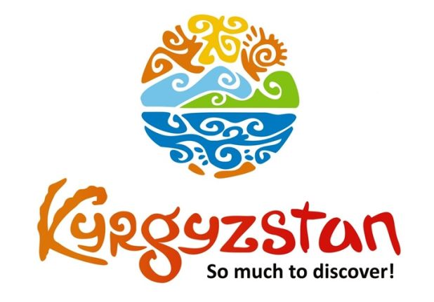**Winter tour to Kyrgyzstan**

Country: **Kyrgyzstan**

Period: **December-March**

**Days: 7 / Nights: 6**

Organizing any complexity of tours to Issyk-Kul, Son-Kul, around Kyrgyzstan and Central Asia. We guarantee you high quality of service and individual approach!

Kyrgyzstan is famous for its ski base in Karakol town during winter months as well as several other places where guests can fully enjoy snow and winter activities, which include skiing, snowboarding, skiing, and riding sledges

#### [Day 1: Arrival to Bishkek](https://concept.kg/en/tours/inbounds/21/#program_collapse_96)

Arrival to Bishkek Airport. Meet a local guide and transfer to the city of Bishkek.  
Sightseeing tour: Main Ala-Too Square, open-air Art Gallery, Erkindik Boulevard, Oak Park and Panfilov Park. Standard check-in to a hotel (at/after 14:00pm).

Overnight at the hotel.

Meals: not included

#### [Day 2: Bishkek - Issyk-Kul](https://concept.kg/en/tours/inbounds/21/#program_collapse_97)

After breakfast, transfer to the Issyk-Kul Lake (drive through the Northern shore).On the way, visit Burana Historical Complex, a small nearby Museum and open air Balbals (stone figures). The Museum collection contains such archeological findings as crockery, coins, sculptures, and other archaeological monuments.  
Upon arrival to Cholpon-Ata, visit the Rukh-Ordo Cultural Complex and open-air Petroglyphs museum (stone inscriptions). Overnight at a hotel.

Meals: breakfast

#### [Day 3: Issyk-Kul - Karakol](https://concept.kg/en/tours/inbounds/21/#program_collapse_98)

After the breakfast, leave towards the city of Karakol through the Issyk-Kul Lake’s Northern shore.  
Sightseeing tour of the old wooden Russian Church (built without nails), Dungan Mosque (Dungan’s are ethnic minority of Muslim Chinese, moved from the West of China) and Kupecheskiy Proezd street that resembles 19th century old Russian village. Further, visit one-village-one-product local shop for handmade souvenir products made by local women of the region. This shop is run by the association of local women who produce wide range of products starting from wild berry jams, handicrafts, herbal soaps and other souvenirs, all using products and materials found in the Issyk-Kul region.

Meals: breakfast

#### [Day 4: Karakol](https://concept.kg/en/tours/inbounds/21/#program_collapse_99)

After the breakfast, depart to the Karakol Ski-Base.  
Only 4WD vehicles can drive up to there (visitors have to change vehicles for 4WD Jeep or 4WD Delica minivan).  
Full day free, enjoy the fresh mountain air, landscape and ski (optional).  
In the afternoon arrival back to Karakol.  
Overnight at a guesthouse.

Meals: breakfast

#### [Day 5: Karakol - Chon Kemin](https://concept.kg/en/tours/inbounds/21/#program_collapse_100)

After breakfast depart to Chon-Kemin Valley through the southern shore of the Issyk-Kul Lake. On the way, stop to visit famous rock formations Jeti-Oguz (Seven Bulls) and Broken Heart.  
Home hosted lunch on the way.  
Upon arrival to Kalmak-Ashuu village, accommodation at eco-lodge Ashu.  
Check-in and short rest.

Meals: breakfast, lunch, dinner

#### [Day 6: Chon Kemin - Bishkek](https://concept.kg/en/tours/inbounds/21/#program_collapse_101)

Morning excursion to the Kalmak-Ashuu Gorge with light hiking (optional).  
Walking tour around the village and introduction to the countryside and lives of local people.  
After lunch, departure back to Bishkek.  
Arrival and accommodation at a hotel.  
Afternoon excursion to the Youth Alley and the colorful Osh Bazar.  
Farewell dinner at a local restaurant followed with folklore show and the Manaschy performance.  
Overnight at a hotel.

Meals: breakfast, lunch, dinner

#### [Day 7: Bishkek - Manas Airport](https://concept.kg/en/tours/inbounds/21/#program_collapse_102)

Transfer to the Airport for the departure flight. Check-out from hotel before 12:00 pm.

Meals: breakfast

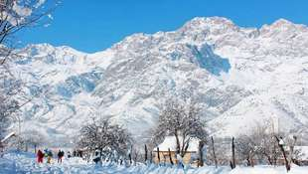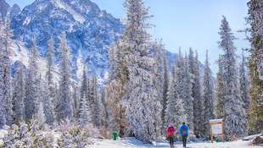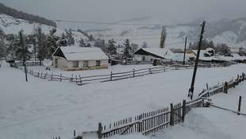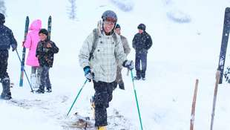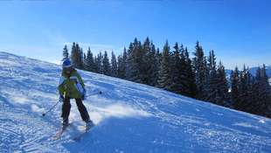

| **GROUP SIZE** | **PRICE IN USD /PER PERSON** |
| --- | --- |
| 2 | 1350 USD |
| 3-4 | 1205 USD |
| 5-6 | 1000 USD |
| 7-8 | 910 USD |
| 9-10 | 860 USD |
| Supplementary for single room | 215 USD |

| **PRICE INCLUDES** |  |
| --- | --- |
| Twin based accommodation | Bishkek - 3* hotel (2 o/n)  Issyk-Kul - 4* hotel (1 o/n) Karakol - guest house (2 o/n)  Chon-Kemin - guest house (1 o/n) |
| Transport | Land transportation by air-conditioned non-smoking vehicle |
| Local guide services (Eng/Russ) | Included |
| Meals | B&B + lunch and dinner on Days 5 and 6 |
| Entrance fees & excursions | Included |
| Bottled water | 1 liter person/day |
| Foklore show in Bishkek | Included (40 min) |

| **PRICE EXCLUDES** |  |
| --- | --- |
| International flights | Not included |
| Visa support letter (if required) | Not included |
| Visa fees | Not included |
| Early check-in, late/check-out on arrival/departure days | Could be arranged upon request for additional fee |
| Meals other than stated/beverages with meals | Not included |
| Ski pass in Karakol Ski Base | From 20$/per person/per day |
| Skiing equipment | From 20$/per person/per day |
| Supplementary for Half Board | 65$ per person |
| Supplementary for Full Board | 115$ per person |
| Personal expenses | Not included |
| Tips to guide/driver (optional) | Not included |

**Contact information:**

[www.travelscruiser.com](http://www.travelscruiser.com)

Phone (24/7): +996 …………., +996 ……….

E-mail: [info@travelscruiser.com](mailto:info@travelscruiser.com)